**McKenzie - PAD**

**Database**

**System Design Documentation**

**Version 1.3**

**2017-05-16**

**McKenzie College SWTS1104**

**Author: Kyle Gunton**

# Revision History

|  |  |  |  |
| --- | --- | --- | --- |
| **Date** | **Version** | **Author** | **Comments** |
| 2017-05-11 | 1.0 | Kyle Gunton | First Revision |
| 2017-05-12 | 1.1 | Kyle Gunton | Added contents to 4.0 Body. Updated 1.3 Context, 2.0 References, and 3.0 Glossary. |
| 2017-05-15 | 1.2 | Kyle Gunton | Added Design overlay and other minor changes |
| 2017-05-16 | 1.3 | Kyle Gunton | Made changes based on feedback |
|  |  |  |  |
|  |  |  |  |
|  |  |  |  |

Revision History 2

1.0 Introduction 6

1.1 Purpose 6

1.2 Scope 6

1.3 Context 6

1.4 Summary 6

2.0 References 7

3.0 Glossary 7

4.0 Body 8

4.1 Identified Stakeholders and Design Concerns 8

4.1.1 Stakeholders 8

4.1.2 Design Concerns 8

4.2 Design Views 8

4.3 Design Viewpoints 9

4.3.1 Introduction 9

4.3.2 User Viewpoint 9

4.3.2.1 User Use Case Diagram 9

4.3.3 Administrator Viewpoint 10

4.3.2.2 Administrator Use Case Diagram 10

4.4 Design Rationale 10

4.5 Design Languages 10

4.6 Design Overlay 11

4.6.1 Database Tables and Contents 11

4.6.1.1 MonsterClass 12

4.6.1.2 MonsterInstance 14

4.6.1.3 Attribute 14

4.6.1.4 MonsterType 15

4.6.1.5 ActiveSkill 15

4.6.1.6 LeaderSkill 15

4.6.1.7 AwokenSkill 15

4.6.1.8 AwokenSkillList 16

4.6.1.9 EvolutionTree 16

4.6.1.10 Player 17

4.6.1.11 Team 17

4.6.1.12 Badge 18

4.6.1.13 LatentSkill 18

4.6.1.14 LatentSkillList 18

Table of Figures

Figure 1.3.1 5

Figure 4.3.2.1 8

Figure 4.3.2.1 9

Figure 4.6.1.1 10

# 1.0 Introduction

## 1.1 Purpose

To identify the design and features of the McKenzie – PAD database.

## 1.2 Scope

In the Puzzles and Dragons database, a user will be able to create a player account, add and modify their monsters, create and modify teams using those monsters, and compare those teams to other monsters.

## 1.3 Context

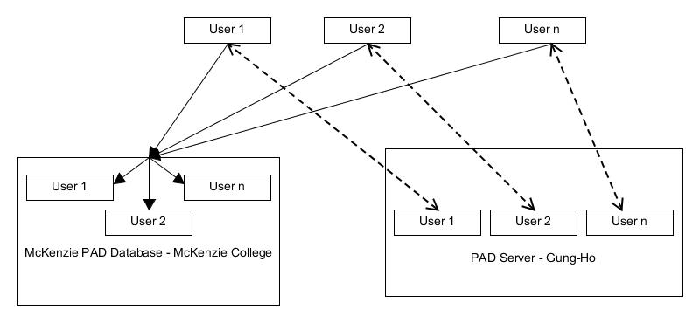

Figure 1.3.1

The McKenzie PAD Database will serve as a third-party application that will allow a user to view and interact with other players’ monsters, teams, and player information (name and rank).

## 1.4 Summary

The PAD database will be accessible through an online web interface. An user will be able to create a player account, view details about monsters they both own or don’t own, add and modify their monsters, create and modify teams using those monsters, and compare those teams to other monsters.

# 2.0 References

* IEEE Standard for Information Technology—Systems Design—Software Design Descriptions 1016™-2009 (Revision of IEEE Std. 1016-1998):

<https://drive.google.com/open?id=0BwTtk4_BHKSZRzIyXy03cWp2c0E&authuser=0>

* Puzzles & Dragons X: [http://www.puzzledragonx.com](http://www.puzzledragonx.com/)

# 3.0 Glossary

**Abbreviations**

* PK – Primary Key
* FK – Foreign Key
* OMG – Object Management Group
* UML -Unified Modeling Language
* PAD – Puzzles & Dragons
* ID – Identity
* SDD – Software Design Document
* SRS – Software Requirements Specifications
* IEEE – Institute of Electrical and Electronics Engineers
* Std. – Standard
* Int – Integer
* Varchar – Variable Character Field

**Definitions**

* Primary Key: A unique identifier used to define a record within a table.
* Surrogate Key: A field created to be a primary key when there are no suitable fields to be the primary key.
* Foreign Key: A unique identifier used to access a record within another table.
* Table: A set of data structures used to store and manage information. Made of fields and columns.
* Field: A structure within a table in which information is stored
* Column (In Database Table): A set of data values with the same properties
* NULL: A value that is either not known or is unrequired
* Monster: An unit used in-game
* Player: An account that contains a rank, name, Unique ID, starting attribute, magic stones, coins, monster points, stamina, and monster instances.
* Rank: An integer value determined by your current exp.
* ID: A unique integer identifier granted to each player upon account creation.
* Starting attribute: Determines player’s time group as well as their ID
* Magic Stones: In-game currency used to purchase monsters, refill stamina, increase friend slots, and to increase monster box slots.
* Coins: In-game currency used to purchase dungeons and upgrade monsters.
* Monster points: In-game currency used to purchase monsters.
* Stamina: an integer value based on level that allows you to enter dungeons only when it is sufficient.
* Active Skill: An ability monsters can use in dungeons to modify the board, the player or the enemies.
* Leader Skill: An ability that buffs the player’s team based on the leader monster.
* Awoken Skill: A boost granted to a monster.
* Latent Awoken Skills: A type of awoken skill that you assign to a monster.
* Monster Types: Monsters have 1-3 types. There are currently 12 different types a monster may have.
* Attribute: All monsters have a primary element and they can have a secondary element. There are 5 elements that can be chosen form. Fire, Water, Wood, Light, and Dark.
* Monster Name: A unique identifier for each blueprint of a monster (if only by case).
* Monster ID: An unique integer used to indicate a monster

# 4.0 Body

## 4.1 Identified Stakeholders and Design Concerns

## 4.1.1 Stakeholders

* Users of PAD
* McKenzie PAD Database Team
* Administrator

## Design Concerns

* Accuracy of information.
* Unable to access information directly from the Gung-Ho PAD Database Server.
* Ease of use

## 4.2 Design Views

User

* Monsters
* Teams
* Account
  + Player Creation
  + Player Information
* Other players Teams

Management

* New content
* Updates (to database)
  + Monster Classes
  + Skills (Leader, Active, Awoken, Latent)
  + Monster Types
* Updating Monster Classes
* Adding Monster Classes
* Managing User Accounts
* Managing other Information in PAD Database Tables

## Design Viewpoints

### Introduction

In this section, two main viewpoints will be elaborated on. These are User Viewpoints as well as Administrator Viewpoints

### User Viewpoint

#### User Use Case Diagram

The user will be able interact with the Database and manage information directly related to their account.

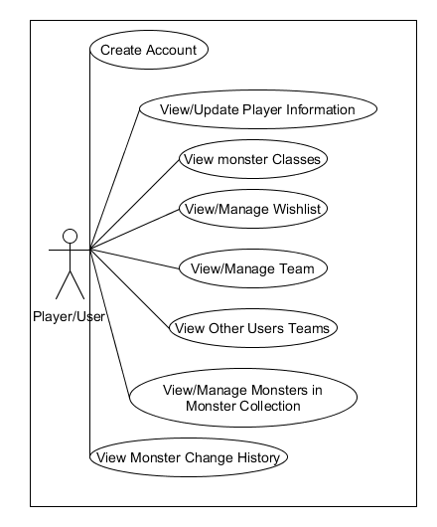

Figure 4.3.2.1

### Administrator Viewpoint

#### 4.3.2.2 Administrator Use Case Diagram

The Administrator will be able to manage, modify, and add information in the database as needed.

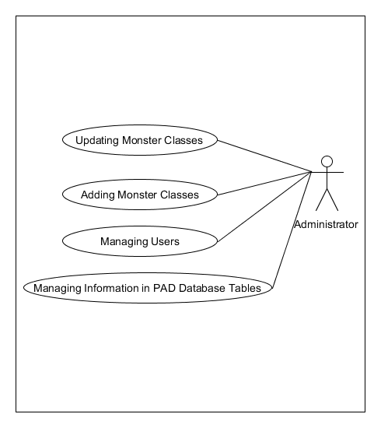

Figure 4.3.2.2

## 4.4 Design Rationale

N/A

## 4.5 Design Languages

Unified Modeling Language (UML) is used as part of design viewpoint.

DB(Database) Schema.

## 4.6 Design Overlay

### 4.6.1 Database Tables and Contents

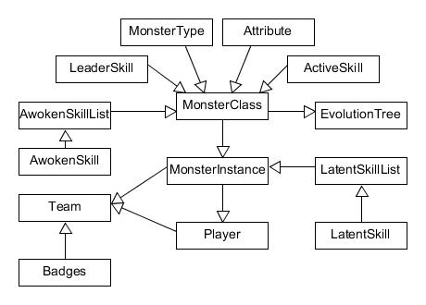

Info from -> used in

Figure 4.6.1.1

#### 4.6.1.1 MonsterClass

|  |  |  |  |  |  |
| --- | --- | --- | --- | --- | --- |
| Column Name | Data Type | NULL or Not | Key | Foreign Key Relation | Description |
| MonsterClassID | int | Not NULL | PK |  | Unique identifier for monster. |
| MonsterName | varchar(100) | Not NULL |  |  | Identifier for monster. |
| Rarity | int | Not NULL |  |  | Indicator of commonality |
| PriAttribute | varchar(50) | Not NULL | FK | Attribute.AttributeName | Monsters first element |
| SecAttribute | varchar(50) | NULL | FK | Attribute.AttributeName | Monsters second element |
| PriMonsterType | varchar(50) | Not NULL | FK | MonsterType. MonsterTypeName | Monsters first Monster type |
| SecMonsterType | varchar(50) | NULL | FK | MonsterType. MonsterTypeName | Monsters second Monster type |
| TerMonsterType | varchar(50) | NULL | FK | MonsterType. MonsterTypeName | Monsters third Monster type |
| MaxExperience | int | Not NULL |  |  | Total experience needed for max level |
| MaxLevel | int | Not NULL |  |  | Highest level the monster can obtain. |
| MonsterCost | int | Not NULL |  |  | A value used to limit the monsters that you can place on a team. |
| ASListID | int | NULL | FK | AwokenSkillList.ASListID | A foreign key to access a monsters’ awoken skills |
| LeaderSkillName | varchar(100) | NULL | FK | LeaderSkill. LeaderSkillName | A foreign key to access a monsters’ Leader skill |
| ActiveSkillName | varchar(100) | NULL | FK | ActiveSkill.ActiveSkillName | A foreign key to access a monsters’ Active skill |
| MaxATK | int | Not NULL |  |  | Value of a monsters’ attack at max level without any boosts from other. |
| MinATK | int | Not NULL |  |  | Value of a monsters’ attack at level 1 without any boosts from other. |
| GrowthRateATK | int | Not NULL |  |  | Value modifier for a monsters’ attack grows upon leveling up. |
| MaxHP | int | Not NULL |  |  | Value of a monsters’ health at max level without any boosts from other. |
| MinHP | int | Not NULL |  |  | Value of a monsters’ health at level 1 without any boosts from other. |
| GrowthRateHP | int | Not NULL |  |  | Value modifier for a monsters’ health grows upon leveling up. |
| MaxRCV | int | Not NULL |  |  | Value of a monsters’ recovery at max level without any boosts from other. |
| MinRCV | int | Not NULL |  |  | Value of a monsters’ recovery at level 1 without any boosts from other. |
| GrowthRateRCV | int | Not NULL |  |  | Value modifier for a monsters’ recovery grows upon leveling up. |
| MaxCoinValue | int | Not NULL |  |  | The coin sell value of a monster at max level with no + stats |
| MinCoinValue | int | Not NULL |  |  | The coin sell value of a monster at level 1 with no + stats |
| MaxExperienceValue | int | Not NULL |  |  | The feed experience value of a monster at max level with no + stats |
| MinExperienceValue | int | Not NULL |  |  | The feed experience value of a monster at level 1 with no + stats |
| MonsterPointValue | int | Not NULL |  |  | The amount of monster points gained by selling this monster |
| LSSlots | int | Not NULL |  |  | The number of latent skill slots are available for this monster. Default is 5 |

A collection of blueprints of all monsters’ base information is stored in this table.

#### 4.6.1.2 MonsterInstance

|  |  |  |  |  |  |
| --- | --- | --- | --- | --- | --- |
| Column Name | Data Type | NULL or Not | Key | Foreign Key Relation | Description |
| InstanceID | int | NULL | PK |  | Unique identifier for every separate monster instance. |
| PlayerID | int | NULL | FK | Player.PlayerID | Foreign key to specify which player owns a monster |
| MonsterClassID | int | NULL | FK | MonsterClass.MonsterClassID | Foreign key to specify a monsters’ class |
| CurrentExperience | int | NULL |  |  | Amount of experience points a monster currently has. |
| PlusATK | int | NULL |  |  | Bonus stat boost for attack. Can go up to +99 and the attack is 5x the +# |
| PlusRCV | int | NULL |  |  | Bonus stat boost for health. Can go up to +99 and the attack is 10x the +# |
| PlusHP | int | NULL |  |  | Bonus stat boost for attack. Can go up to +99 and the attack is 3x the +# |
| SkillsAwoke | int | NULL |  |  | Number of awoken skills active |
| AssistMonsterID | int | Not NULL | FK | MonsterInstance.InstanceID | Instance ID of the monsters assisting monster |
| SkillLevel | int | Not NULL |  |  |  |
| LSListID | int | Not NULL | FK | LatenSkillList.InstanceID |  |
| ActiveSkillCoolDown | int | NULL |  |  |  |
| CurrentHP | int | NULL |  |  |  |
| CurrentATK | int | NULL |  |  |  |
| CurrentRCV | int | NULL |  |  |  |
| PlusHPAmount | int | NULL |  |  |  |
| PlusATKAmount | int | NULL |  |  |  |
| PlusRCVAmount | int | NULL |  |  |  |
| CurrentLevel | int | NULL |  |  |  |

A collection of monsters based on blueprints from MonsterClass that has been given a unique instance ID and player ID.

#### 4.6.1.3 Attribute

|  |  |  |  |  |
| --- | --- | --- | --- | --- |
| Column Name | Data Type | NULL or Not | Key | Description |
| AttributeName | varchar(50) | NULL | PK | Unique identifier for monsters’ attribute(s)/element(s) |

All monsters have a primary and a possible secondary element that they will pull from this table

#### 4.6.1.4 MonsterType

|  |  |  |  |  |
| --- | --- | --- | --- | --- |
| Column Name | Data Type | NULL or Not | Key | Description |
| MonsterTypeName | varchar(50) | NULL | PK | Unique identifier for monsters’ type(s) |

All monsters currently have 1-3 types consisting of the records d they pull from this table

#### 4.6.1.5 ActiveSkill

|  |  |  |  |  |
| --- | --- | --- | --- | --- |
| Column Name | Data Type | NULL or Not | Key | Description |
| ActiveSkillName | varchar(100) | NULL | PK | Unique identifier for monsters’ active skill |
| ActiveSkillDesc | varchar(MAX) | NULL |  | In-game description of monsters’ active skill |
| ActiveSkillMaxLevel | int | NULL |  | Maximum level a skill can reach |
| ActiveSkillMaxCoolDown | int | NULL |  | Turns a skill takes to charge at level 1 |

Monster classes pull the information on their active skills from this table

#### 4.6.1.6 LeaderSkill

|  |  |  |  |  |
| --- | --- | --- | --- | --- |
| Column Name | Data Type | NULL or Not | Key | Description |
| LeaderSkillName | varchar(100) | NULL | PK | Unique identifier for monsters’ leader skill |
| LeaderSkillDesc | varchar(MAX) | NULL |  | In-game description of monsters’ leader skill |

All monsters can have a leader skill. The leader skill is an ability that grants the user a boost when certain conditions are met.

#### 4.6.1.7 AwokenSkill

|  |  |  |  |  |
| --- | --- | --- | --- | --- |
| Column Name | Data Type | NULL or Not | Key | Description |
| AwokenSkillName | varchar(100) | NULL | PK | Unique identifier for monsters’ awoken skill |
| AwokenSkillDesc | varchar(MAX) | NULL |  | In-game description of monsters’ awoken skill |

Awoken skills are small boosts attached to monsters. All monster instances of the same base monster class have the same awoken skills in the same order. A monster can currently have up to nine.

#### 4.6.1.8 AwokenSkillList

|  |  |  |  |  |  |
| --- | --- | --- | --- | --- | --- |
| Column Name | Data Type | NULL or Not | Key | Foreign Key Relation | Description |
| ASListID | int | NULL | PK |  | Surrogate key to identify the monster class the list belongs to |
| AwokenSkillOne | varchar(100) | NULL | FK | AwokenSkill.AwokenSkillName | First awoken skill a monster may have |
| AwokenSkillTwo | varchar(100) | Not NULL | FK | AwokenSkill.AwokenSkillName | Second awoken skill a monster may have |
| AwokenSkillThree | varchar(100) | Not NULL | FK | AwokenSkill.AwokenSkillName | Third awoken skill a monster may have |
| AwokenSkillFour | varchar(100) | Not NULL | FK | AwokenSkill.AwokenSkillName | Fourth awoken skill a monster may have |
| AwokenSkillFive | varchar(100) | Not NULL | FK | AwokenSkill.AwokenSkillName | Fifth awoken skill a monster may have |
| AwokenSkillSix | varchar(100) | Not NULL | FK | AwokenSkill.AwokenSkillName | Sixth awoken skill a monster may have |
| AwokenSkillSeven | varchar(100) | Not NULL | FK | AwokenSkill.AwokenSkillName | Seventh awoken skill a monster may have |
| AwokenSkillEight | varchar(100) | Not NULL | FK | AwokenSkill.AwokenSkillName | Eighth awoken skill a monster may have |
| AwokenSkillNine | varchar(100) | Not NULL | FK | AwokenSkill.AwokenSkillName | Ninth awoken skill a monster may have |

A list of a monster classes’ awoken skills in order from one to nine.

#### 4.6.1.9 EvolutionTree

|  |  |  |  |  |  |
| --- | --- | --- | --- | --- | --- |
| Column Name | Data Type | NULL or Not | Key | Foreign Key Relation | Description |
| NextMonsterID | int | Not NULL | PK |  | Monster class the monster being evolved will become |
| BaseMonsterID | int | Not NULL | FK | MonsterClass.MonsterClassID | Current class of a monster instance before evolution |
| EvoMaterialIDOne | int | Not NULL | FK | MonsterClass.MonsterClassID | First monster required for evolution |
| EvoMaterialIDTwo | int | NULL | FK | MonsterClass.MonsterClassID | Second monster required for evolution |
| EvoMaterialIDThree | int | NULL | FK | MonsterClass.MonsterClassID | Third monster required for evolution |
| EvoMaterialIDFour | int | NULL | FK | MonsterClass.MonsterClassID | Fourth monster required for evolution |
| EvoMaterialIDFive | int | NULL | FK | MonsterClass.MonsterClassID | Fifth monster required for evolution |
| MinLevel | int | Not NULL |  |  | Minimum level a monster requires to evolve |
| Devolveable | bit | Not NULL |  |  | True or False for if a monster can “evolve” to it’s previous form |
| LevelReset | bit | Not NULL |  |  | True or False for if a monster will return to level 1 after evolving |

Monsters generally have the ability to evolve/devolve (change into another monster) under certain circumstances. This table records the different stages a monster instances may go through.

#### 4.6.1.10 Player

|  |  |  |  |  |
| --- | --- | --- | --- | --- |
| Column Name | Data Type | NULL or Not | Key | Description |
| PlayerID | int | NULL | PK | Unique Identifier for each player |
| PlayerRank | int | NULL |  | Players current rank |
| PlayerName | varchar(50) | Not NULL |  | Players current name (Can be changed) |
| PlayerAttribute | varchar(50) | Not NULL |  | The attribute of the players starting monster. Helps determine PlayerID |

This table records information important to identifying a player including their in-game id, Name, and rank amongst others.

#### 4.6.1.11 Team

|  |  |  |  |  |  |
| --- | --- | --- | --- | --- | --- |
| Column Name | Data Type | NULL or Not | Key | Foreign Key Relation | Description |
| TeamInstanceID | int | NULL | PK |  |  |
| PlayerID | int | NULL | FK | Player.PlayerID |  |
| TeamName | varchar(50) | Not NULL |  |  |  |
| LeaderMonster | int | NULL | FK | MonsterInstance.InstanceID |  |
| SubMonsterOne | int | Not NULL | FK | MonsterInstance.InstanceID |  |
| SubMonsterTwo | int | Not NULL | FK | MonsterInstance.InstanceID |  |
| SubMonsterThree | int | Not NULL | FK | MonsterInstance.InstanceID |  |
| SubMonsterFour | int | Not NULL | FK | MonsterInstance.InstanceID |  |
| BadgeName | varchar(50) | Not NULL |  |  |  |
| TeamHP | int | NULL |  |  |  |
| FireATK | int | NULL |  |  |  |
| WaterATK | int | NULL |  |  |  |
| WoodATK | int | NULL |  |  |  |
| LightATK | int | NULL |  |  |  |
| DarkATK | int | NULL |  |  |  |
| TeamRCV | int | NULL |  |  |  |
| TeamCost | int | NULL |  |  |  |

The team table is made up of the player’s id it belongs to, its name and anywhere from one to five monster instances. It also includes a badge that will give a boost to the team in dungeons.

#### 4.6.1.12 Badge

|  |  |  |  |  |
| --- | --- | --- | --- | --- |
| Column Name | Data Type | NULL or Not | Key | Description |
| BadgeName | varchar(50) | NULL | PK | Unique identifier for badge that can be used on a team |
| BadgeDesc | varchar(MAX) | NULL |  | In-game description of a badges effect on a team |

Badges may be assigned to teams (one badge may go to many teams) to grant that team a boost (stat, monster cost, etc.)

#### 4.6.1.13 LatentSkill

|  |  |  |  |  |
| --- | --- | --- | --- | --- |
| Column Name | Data Type | NULL or Not | Key | Description |
| LatentSkillName | varchar(50) | NULL | PK | Unique identifier for a latent skill |
| LatentSkillDesc | varchar(MAX) | NULL |  | In-game description of latent skills effect |
| LSSlotsReq | int | NULL |  | Number of slots a latent skill requires to be added to a monster instance. |

All monster instances can have at least 5 latent skills and up to 6 under certain circumstances. Lists all the latent skills available and their descriptions.

#### 4.6.1.14 LatentSkillList

|  |  |  |  |  |  |
| --- | --- | --- | --- | --- | --- |
| Column Name | Data Type | NULL or Not | Key | Foreign Key Relation | Description |
| InstanceID | int | NULL | PK |  | Unique identifier used to identify the monster that own the set of latent skills |
| LatentSkillOne | varchar(50) | Not NULL | FK | LatentSkill.LatentSkillName | Monsters first latent skill |
| LatentSkillTwo | varchar(50) | Not NULL | FK | LatentSkill.LatentSkillName | Monsters second latent skill |
| LatentSkillThree | varchar(50) | Not NULL | FK | LatentSkill.LatentSkillName | Monsters third latent skill |
| LatentSkillFour | varchar(50) | Not NULL | FK | LatentSkill.LatentSkillName | Monsters fourth latent skill |
| LatentSkillFive | varchar(50) | Not NULL | FK | LatentSkill.LatentSkillName | Monsters fifth latent skill |
| LatentSkillSix | varchar(50) | Not NULL | FK | LatentSkill.LatentSkillName | Monsters sixth latent skill |
| ExtraSlot | bit | NULL |  |  | Determines whether a monster may have a sixth latent skill slot |

A collection of latent skills that belong to a specific monster instance. A latent skill may take up multiple slots.